**Best Buy Fitbits[1]**

**During the next four months Best Buy requires, respectively, 500, 650, 1000 and 700 units of Fitbits. No backlogging is allowed (that is, Best Buy’s requirements must be met on time). Production costs are $50, $80, $40, and $70 per Fitbit during these months. The storage cost from one month to the next is $20 per unit (assessed on ending inventory). It is estimated that each Fitbit unit on hand at the end of month 4 can be sold for $60. Assume there is no beginning inventory and determine how to minimize the net cost incurred in meeting the demands for the next four months.**

**Discussion:**

**The objective is to design a multi-period production plan in such a way that Fitbit Co. reduces its cost. Fitbit Co. is producing Fitbit’s to meet Best Buy’s requirements on time. The input values given in this problem are the “demand” received from Best Buy, the “production cost” to produce Fitbit units in that month, and the “storage cost” for any inventory at the end of a month.**

**On top of these inputs it was mentioned that there is no beginning inventory for month-1, and it was estimated that each Fitbit unit on hand at the end of month-4 can be sold for $60.**

**Therefore, we must make sure that the summation of a month’s beginning inventory and produced units are greater than or equal to the demand for that month. This is the important constraint needed to solve this problem. The screenshot below illustrates how to set up the model to calculate the month-end inventory.**

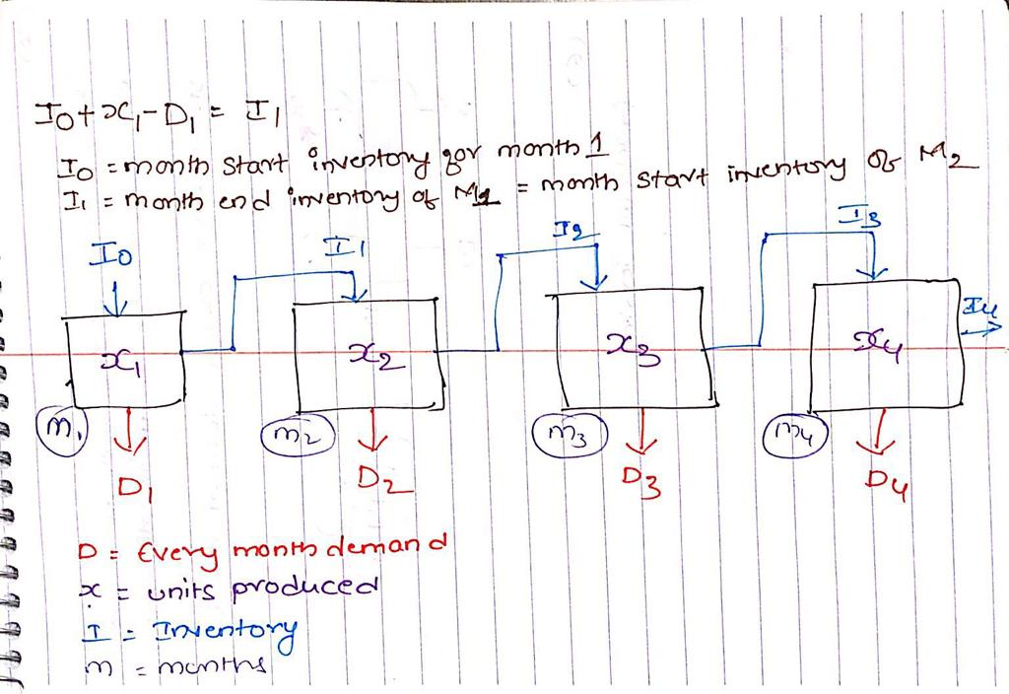

**Mathematical Model:**

*Parameters (Inputs):*

$$i ϵ 1,2,3,4 \left(Index for months\right)$$

$D_{i} :Demand in month i$

$$C_{i} :Production cost per Fitbit unit in month i$$

$$S :Storage cost per Fitbit unit$$

$$P :Selling price for leftover Fitbits units at the end of month 4$$

$$I_{0} :Beginning Inventory of month 1 , I_{o}=0$$

*Calculated Variables:*

$$I_{i} :Month-end Inventory in month i; {{I_{i}=(I}_{i-1}+x}_{i}-D_{i})$$

*Decision Variables:*

$$x_{i} :Number of Fitbit units produced in each month i$$

*Objective:*

$$Minimize Total Cost=\left[\sum_{i=1}^{4}{\left(x_{i}*C_{i}\right)+\left(I_{i}*S\right)} \right]-\left[I_{4}*P\right]$$

*Constraints:*

$$x_{i}≥0; \left(1\right)Non Negative constraint$$

$${{(I}_{i-1}+x}_{i}-D_{i})≥0 (2)Demand constraint$$

*Excel Implementation:*

Please find the attached spreadsheet for solution. 

As per the optimization model Fitbit Co. can produce 1150 Fitbit units in month-1 and 1700 units in month-3.

Because the Fitbit unit production cost in month-2 is higher than the summation of month production cost and storage cost, the optimal solution suggests producing 1150 units in month-1, to account for and manage the month-2 demand as well. Similarly, Solver suggests producing Fitbit units required for month-4 in month-3. If there were any constraints with respect to the production units per month, there would have been a different solution from solver.

1. This exercise problem and related solutions were originally developed by Ramesh Alla based on Practical Management Science 5th Edition. This vision is revised by Nowed Patwary.